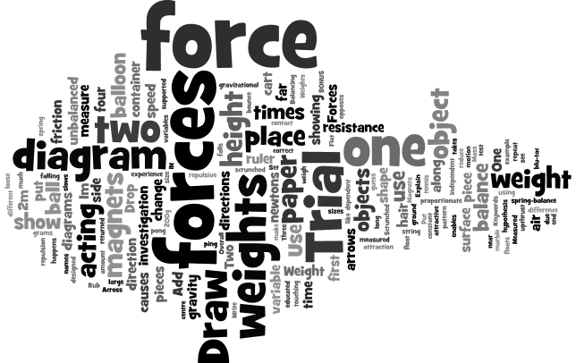
NAME:
Weight is a force. Forces are measured in newtons. Measure the weight of these objects using the spring-balance. Draw each of the objects and the force in newtons like in the example below.
Spring-balance or Forcemeter
Is Weight a contact or noncontact force? _____________________
BONUS: If 1N = 100grams how much does each object weigh in grams?
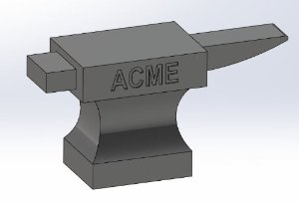
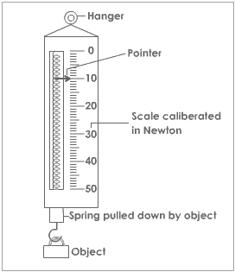
500N

Name of Object:

Weight in grams:

Name of Object:

Weight in grams:

Name of Object:

Weight in grams:

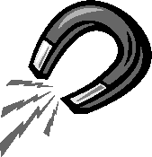
Magnets

Put the magnets together

- Do the magnets have to be touching in order to experience the force?
_______________________________________
- How can you change the forces between two magnets from attractive to repulsive?
_______________________________________
- What is the force called?
_______________________________________
- Draw two diagrams to show the forces between magnets in the two cases or attraction and repulsion.
Repulsion

Attraction

Balancing Weights
Set up the ruler with the fulcrum (balancing point) in the very centre. Use blu-tac to attach two weights to one end. How far along do you have to place one weight on the other side to balance the ruler? _____________
If you three weights on one side how far along do you have to place the one weight? _____________

Hypothesise (make an educated guess) where you would put one weight to balance four weights: __________________________________________________________

Bonus: If you have time test this hypothesis. Is it supported (that is, were you correct)? ________. Use two weights to balance the four weights.
Fulcrum
Ruler
Weight

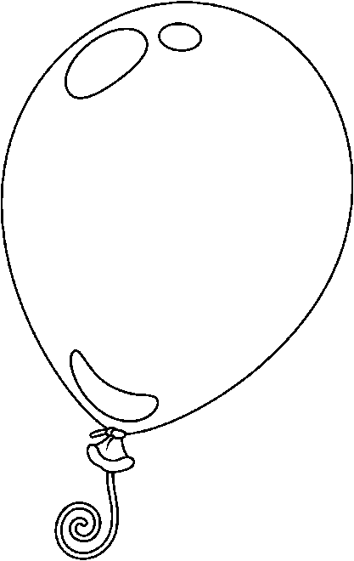
Rub the balloon on your clothes and then put the balloon near some loose hair.
Balloon

- Draw a diagram of what happens.
- What causes the hair to stick to the balloon?
____________________________________
- Add the names of the forces acting to the diagram and use arrows to show the directions of the forces.

Drop the tennis ball from a 2m height and measure the height of the first bounce. Do this 3 times and repeat at a 1m height.
Tennis Ball Drop
Height | Trial 1 | Trial 2 | Trial 3
2m
1m

In this investigation what is the independent variable? _______________
What is the dependent variable? ________________________________
What are some of the controlled variables? ________________________
__________________________________________________________
Why isn’t all the gravitational force returned in the rebound?
__________________________________________________________
Draw a diagram of the investigation below:

You should have one piece of paper that is scrunched up into a ball and one piece that is flat.
Falling Paper
Drop the pieces of paper from shoulder height and time how long it takes to fall to the ground.
- Write the times below:
 | Trial One | Trial Two | Trial Three
Scrunched
Flat

- What forces are acting on the paper as it falls? ____________ and _____________.
- Add these forces to the diagrams, and use arrows to show the directions and proportionate size.
- Explain why there is a difference in the times of the two pieces of paper.
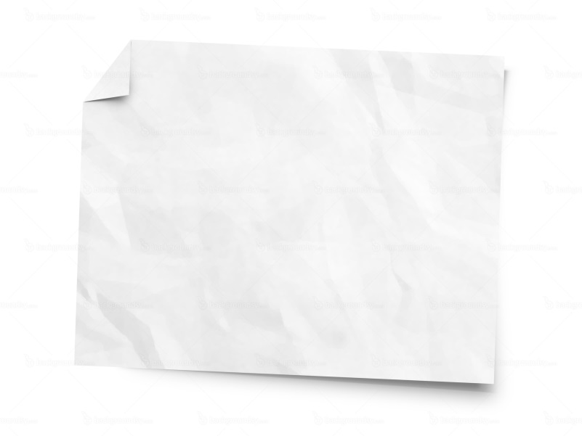
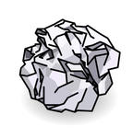
________________________________________________________________________________________________

Will it Float?

In the first container of water place the ping pong ball. In the second place the marble. Which one floats? _____________ Why? _______________.

Draw a diagram for each container showing the forces acting (their direction and their relative sizes).
Keywords you should use in your diagram: gravity, upthrust, resistance

Overall are the forces balanced or unbalanced? ___________________

How Strong is the Force?
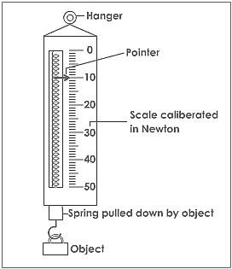
Use the spring balances to measure the force the weights exert on the cart.
 | Newtons Measured
Mass added (g) | Trial One | Trial Two
50 g
100 g
150 g
200g

Can you see a pattern? _______________________________________
Draw a diagram below showing the different forces acting on the cart, string and weights.

Forces

Across

1. The forces when an object is stationary or at constant speed
4. A shape designed to reduce air resistance
5. Can change an object's speed, shape or direction
8. A surface with very little friction
9. The force on an object due to gravity

Down

2. A force which slows objects falling through air
3. The winning force if the forces are unbalanced
5. A force which opposes motion
6. A force which enables an object to float
7. A surface which causes a large amount of friction

